CS696 – Graduate Directed Projects
Website Usability Sample
Based upon HCI Assignment 5, Spring 2014

Types of Usability Tests

Objective Measures
- Task time
- Problem counts
- Keystroke counts
Subjective Measures
- Opinion poll
- Score for understanding
- Guideline adherence

Part 1: Planning the Usability Test
Test Users | Who are the test users?  How did you select them?  Where did you find them?
Facilitator:  Log keeper:  Observer(s): | Who is the facilitator?  Who is the log keeper?  Who are the observers?
Test site: | Where will the usability test be conducted?
Test Task 1 | What is the task you want the tester to complete?  How will the task be presented? (Ex: verbal, written, other)
Test Task 2 | What is the task you want the tester to complete?  How will the task be presented? (Ex: verbal, written, other)
Opinion poll Questions | Replace this text with a list of questions to be asked for the opinion poll
Score of understanding | Replace this text with a list of items to be used to check for understanding, and how each will be scored. For example, what constitutes an ‘A’ rating, what constitutes a ‘B’ rating, etc. for each of the items.
Guideline adherence | Replace this text with a list of guidelines the tester will use to determine guideline adherence.

Part 2: Carry Out
Welcome and introduction | Replace this text with what you will say to the testers prior to the test. Try to put them at ease and make sure they understand the purpose of the test.
Roles of the Team | Facilitator – what are the duties  Log Keeper – what are the duties  Observers - what are the duties
Test Task 1 | What is the specific task the tester will be asked to complete? Possibly include more details than what was listed in the plan.
Test Task 2 | What is the specific task the tester will be asked to complete?  Possibly include more details than what was listed in the plan.
Usability Log  Test User 1  Task 1 | Replace this text with a typed version of the usability log. A handwritten log is OK during the test (see example below), but after the test, please type the usability log here.  The log should include the tester name or initials, date and time the test began, and list of any problems that were found during the test.
Usability Log
Test User 1
Task 2
Usability Log
Test User 2
Task 1
Usability Log
Test User 2
Task 1

Usability Log
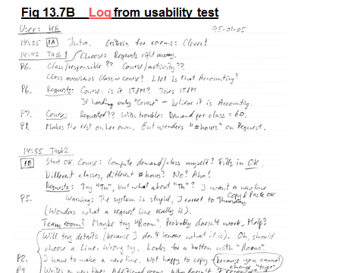
Part 3: Test Report
Objective Measures
1. Task Time Results
Task | User 1 | User 2
Task 1 |  | time
Task 2

2. Keystroke Count Results
Task | keystrokes | System response time | Total task time
Task 1 – User 1 | 6 keystrokes @ 0.6s = 3.6s | 8.0s | 11.6s
Task 1 – User 2
Task 2 – User 1
Task 2 – User 2

3. Problem Count Results - Problems and hit-rates
Below are some examples of how problem counts can be reported. You may choose how you want to represent this, but it should include some sort of table indicating the problems, the severity, and which test user encountered the problem. Graphs are optional, but recommended.

Example 1:
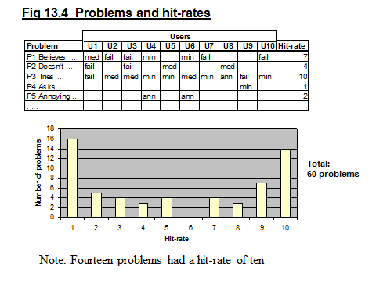
Example 2:
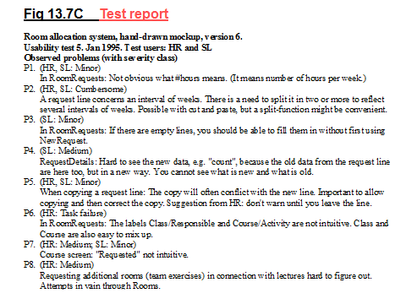
Example 3:
Prob ID | User | Description | Possible solution | Severity
P1 | HR, SL | In RoomRequests: Not obvious what # hours means. | It means number of hours per week | Minor
P2 | HR, SL | A request line concerns an interval of weeks. There is a need to split it into two or more to reflect several intervals of weeks. | Possible with cut and paste, but a split-function might be convenient. | Cumbersome
P3 | SL | In Room Requests: If there are empty lines, you should be able to fill them in without first using NewRequest |  | Minor
etc

Subjective Measures

- Opinion poll - Questionnaire
These are just sample questions. Please come up with your own.
Question | agree | neutral | disagree
The website was easy to learn
The website is easy to use
The website helps me…
It is fun to use
I will recommend it to others
etc

- Score for understanding
These are just sample questions. Please come up with your own
Question | Scale  A-D
What do these error messages mean?
Error message #1
Error message #1
What would happen if …
What is the purpose of this website?
etc

- Guideline adherence
These are just guidelines. Please come up with your own
Guidelines | # of deviations
 | User1 | User2
1. Proper use of color – use two to four colors
2. Clear navigation structure
3. Consistent layout from page to page
4. Use of appropriate images
5. Is the site credible? Trustworthy?
etc

Part 4: Website Analysis
According to the results of the usability test, discuss if the website meets the six usability factors. (Fit for use, ease of learning, task efficiency, ease of remembering, subjective satisfaction, and understandability). Discuss what usability measure(s) were used to determine each usability factor. Justify your analysis with the results of the usability test.

