Installing Ubuntu Server Edition 14.04 as a Virtual Machine
- Before installing Ubuntu Server 14.04, you need to install VirtualBox.
- To install VirtualBox on a laptop or desktop:
- Virtualization Technology needs to be enabled.
- On university laptops this must be enabled for 64-bit virtualization (You may need to request to have this feature turned on if you have a university laptop).
- You can download VirtualBox from virtualbox.org using a web browser (At the time this document was written, the latest version is VirtualBox 4.3.22 for Windows hosts -> x86/amd64). Please download the most current version and install it.
- Once virtualization technology is enabled and VirtualBox is installed, you may continue to install the Ubuntu Server 14.04.
Install Ubuntu Server 14.04:
- Open your web browser.
  - Type Ubuntu server download in the search box.
  - The website provides a “Go to download” option. Click on it.
  - Scroll down and click on Ubuntu Server (not Ubuntu Desktop) on left of the page.
  - Click on download (At the time this document was written the size of Ubuntu Server was 572MB).
- After downloading Ubuntu, open VirtualBox (which you just installed).
  - Select “New”. Next and select “Type” (Linux), “version” (Ubuntu (64 bit)) and provide a meaningful name. Then, click next.
  - Select a memory size for your virtual machine (do not use more than 2GB RAM on university laptops (<2048MB)).
  - Select create a virtual hard drive now.
  - Select VDI.
  - Select dynamically allocated.
  - Select no more than 10GB hard drive on university laptop and create your Virtual Machine (VM).
- Now, your VM should show up in a list in the VirtualBox window.
  - Right click the new VM name that you created, and go to Settings -> System -> Processor.
  - Select no more than 2 processors for university laptops.
  - Next, under settings, select Storage, and select Empty under “Controller: IDE,” then click the small CD icon on the right and side of the screen, and browse to and open the Ubuntu Server .iso file (this is most likely in your Downloads folder).
  - Next, under settings, select Network, and select Bridged as the Network Type.
    - A Bridged network adapter will allow your VM to have its own IP address.
  - Finalize your selections by clicking “ok”.
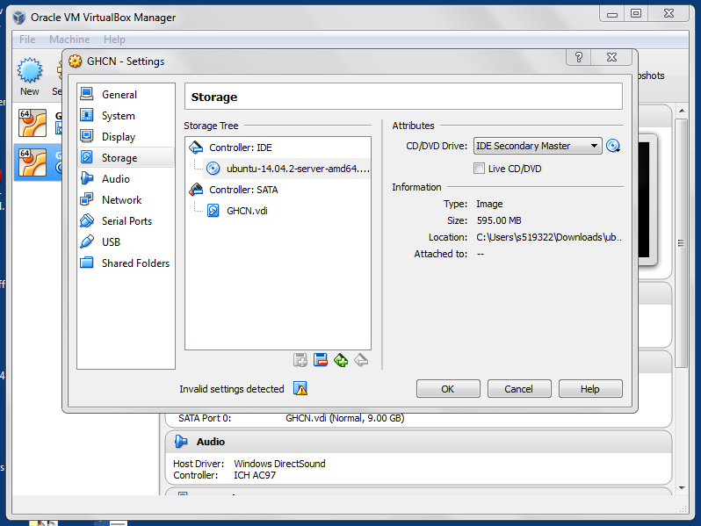

- Next, double click on the name of your VM. This should open your VM and begin installation of Ubuntu Server. 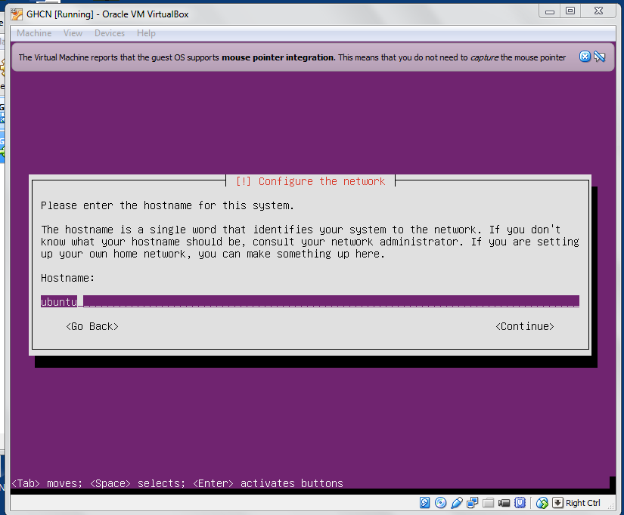
  - Once the installation starts, select English -> install Ubuntu server -> English -> United States ->No -> English (US) ->English(US).
  - After pressing enter, the image on the previous page is displayed.
- At this point, as shown in the image, you will be asked to enter a hostname (hostname is a single word that identifies your system to the network).
  - Create a unique hostname for your Ubuntu Server, then use the tab key to select continue. Once continue is selected, press enter.
  - Next, enter your full name as the “full name of the user”, then select continue and press enter.
  - Enter username for your account, and then continue.
  - Enter a password that you will not forget, verify it and continue.
- Next, confirm your time zone and continue.
- Next, you will be asked to select a partitioning method.
  - Select “Guided – use entire disk and set up LVM”
  - Select the disk to partition, and press enter.
  - Next you will be asked to “Write the changes to disks and configure LVM”. Select yes.
  - Leave the “Amount of volume group to use for guided partitioning” as the provided value and continue.
  - Next, you will be asked to “Write the changes to disk”. Select yes, and continue.
- For the HTTP proxy information, leave it blank, and continue.
- For “Manage upgrades on this system,” select “Install security updates automatically,” and continue.
- For “Software to install” select openSSH server and then continue.
- On successful completion of installation the following image is displayed.
