Name: ______________________________________

Software Engineering II (CS 562)
Exam 1

Part I – True / False, circle T for true or F for false. Statements are intended to have one answer. Evaluate truth based upon the material covered in this class (20 points, 2 points per question).

- T F Agile development may include daily meetings, acceptance testing, iterations that last from one week to one month, and release cycles.
- T F Extreme Programming (XP) is an agile method that focuses on teamwork, especially pair programming, and uses code as one of the main means of communication.
- T F Scrum includes three core development roles – product owner, scrum master, and developers.
- T F An equivalence class is a set of data that represents a single test condition.
- T F Livelock is a condition in which processes needing to use the same resource are all halted because they are all waiting to use that resource. These processes consume no CPU cycles while waiting.
- T F Deadlock may always be avoided by changing the order in which resources are allocated to processes.
- T F The pipe and filter pattern models a stream of data passed through a group of processes referred to as a pipeline.
- T F Model driven development includes creating domain models, ER diagrams, and use cases; refining component interactions, component interfaces, data distribution and functionality, and reusable components; reviewing use cases and architecture feasibility; and finalizing interfaces and class/interaction diagrams.
- T F Design principles include but are not limited to increasing cohesion, decreasing coupling, and anticipating obsolescence.
- T F Software architecture is the process of designing system's global organization, dividing it into subsystems, deciding how subsystems will interact, and determining the interfaces.

Part II – Short and long answer questions (80 points).

- Define the parts of the Model View Controller architecture and provide an example of each part (10 points).

- Below are examples of five types of errors: null condition not handled, off-by-one, improper precision, infinite loop, and improper floating point comparison. For each example list the type of error, and explain why it is of that type. Assume one error per sub-problem, and assume any comments provided are correct (20 points, 4 points each).
A) int n = 10;
double d = 0.0;
for(int i = 0; i < n; i++)
d += 2.0;
if(d == 20.0)
System.out.println("d is 20.0");

B) //Print all the elements in an array.
int [] arr = { 10, 9, 8, 7, 6 };
int n = arr.length;
for(int i = 1; i < n; i++)
System.out.println(arr[i]);

C) //Do processing if "yes" or "no" is provided as input.
Scanner scan = new Scanner(System.in);
while(true){
int input = 0;
System.out.println("Enter yes or no.");
String line = scan.nextLine().trim();
if(line.equals("yes")) input = 1;
else if(line.equals("no")) input = 2;
else input = 3;
switch(input) {
case 1: case 2: case 3:
System.out.println("Invalid input, please enter yes or no.");
default:
break;
}
}

D) //Insert an element at the front of a linked list.
void insert(LLElement e) {
if(head == null)
head = e;
else {
e.next = head;
head = e;
}
}

E) //The following code moves a robot arm designed for surgery

float [] move(float phi, float psi, float theta, float [] vec)
{
float [] retVec = new float[3];
float cosT = Math.cos(theta), sinT = Math.sin(theta);
float cosPhi = Math.cos(phi), sinPhi = Math.sin(phi);
float cosPsi = Math.cos(psi), sinPsi = Math.sin(psi);

retVec[0] = cosT*cosPsi*vec[0] + (-cosPhi*sinPsi + sinPhi*sinT) * vec[1] + (sinPhi*sinPsi + cosPhi*sinT*cosPsi) * vec[2]
retVec[1] = cosT*sinPsi* vec[0] + (cosPhi*cosPsi + sinPhi*sinT*sinPsi)* vec[1] + (-sinPhi*cosPsi + cosPhi*sinT*sinPsi) * vec[2];
retVec[2] = -sinT* vec[0] + sinPhi*cosT* vec[1] + cosPhi*cosT* vec[2];

return retVec;
}

- What is the difference between white/glass box and black box testing (10 points)?

- In your own words and using diagrams describe deadlock, livelock, and how the two are similar and different (10 points).

- Design by contract is an important part of defensive design. When developing methods or code what are the three important guarantees a programmer must make when implementing a design by contract. Describe each of these (10 points).

- Complete the following crossword puzzle (10 points).
Word bank: backlog, sprint, user story, unit test, pair programming, cost-benefit analysis, stakeholders, release
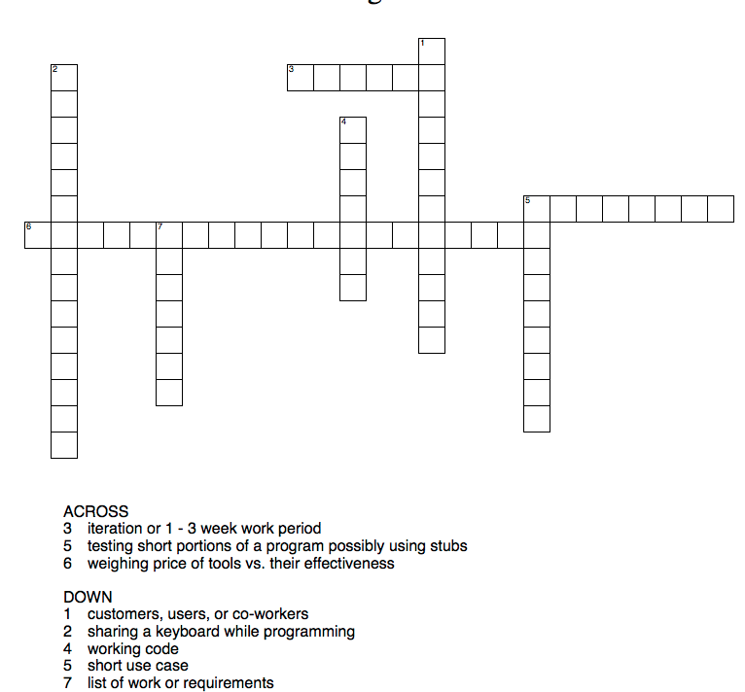

- Describe equivalence classes. What are the equivalence classes and boundary conditions for the following if statement (10 points)?

if( x > 10 && y < 20)
//Do something.

